TRACING THE GROWTH OF THE GLOBAL COMMUNITY: A POPULATION FORECASTING

ANALYSIS

BACHELOR OF SCIENCE IN MATHEMATICS

submitted by,

Team leader: Jacinth Praisy J (Reg. No. 20202141517109)

Team Member 1: Esakkiyammal @ Balasundari A (Reg. No. 202141517105)

Team Member 2: Reena P (Reg. No. 20202141517117)

Team Member 3: Angel V (Reg. No. 20202141517101)

Team Member 4: Gifta Paulin A (Reg. No. 20202141517107)

MENTOR NAME

DR.S.ZION CHELLA RUTH M.Sc., M.Phil., Ph.D., SET.,

Assitant Professor in Mathematics

DEPARTMENT OF MATHEMATICS

NAZARETH MARGOSCHIS COLLEGE AT PILLAYANMANAI

NAZARETH – 628 617.

MANONMANIAM SUNDARANAR UNIVERSITY

Reaccredited with ‘A’ Grade (CGPA 3.13 Out of 4.0) by NAAC (3rd  cycle)

TIRUNELVELI-627 012.

CONTENTS

1. INTRODUCTION

1.1 Overview

1.2 Purpose

2. PROBLEM DEFINITION & DESIGN THINKING

2.1 Empathy Map

2.2 Brainstorming Map

3. RESULT

4. ADVANTAGES AND DISADVANTAGES

5. APPLICATION

6. CONCLUSION

7. FUTURE SCOPE

1. Introduction

1.1 Overview:-

The world’s population is more than three times larger than it was in the mid – twentieth century. The global human reached 8.0 billion in mid – November 2022 from an estimated 2.5 billion people in 1950, adding 1 billion people since 2010 and 2 billion since 1998. The world’s population is expected to increase by nearly 2 billion persons in the next 30 years, from the current 8 billion to 9.7 billion in 2050 and could peak at nearly 10.4 billion in the mid-2080s.

1.2 Purpose:-

Population forecasts try to estimate the rate of population growth. However, unpredictable factors can change fertility rates, mortality rates, or migration rates, which can cause difficulty in forecasting. Certain government policies are making it easier and more socially acceptable to use contraception and abortion methods. Likewise, some countries are instituting pro – natalist policies to encourage fertility. Malthusian catastrophe refers to a scenario where overpopulation would compromise global food security, leading to encourage fertility.

2. Problem Definition & Design Thinking

2.1 Empathy Map :-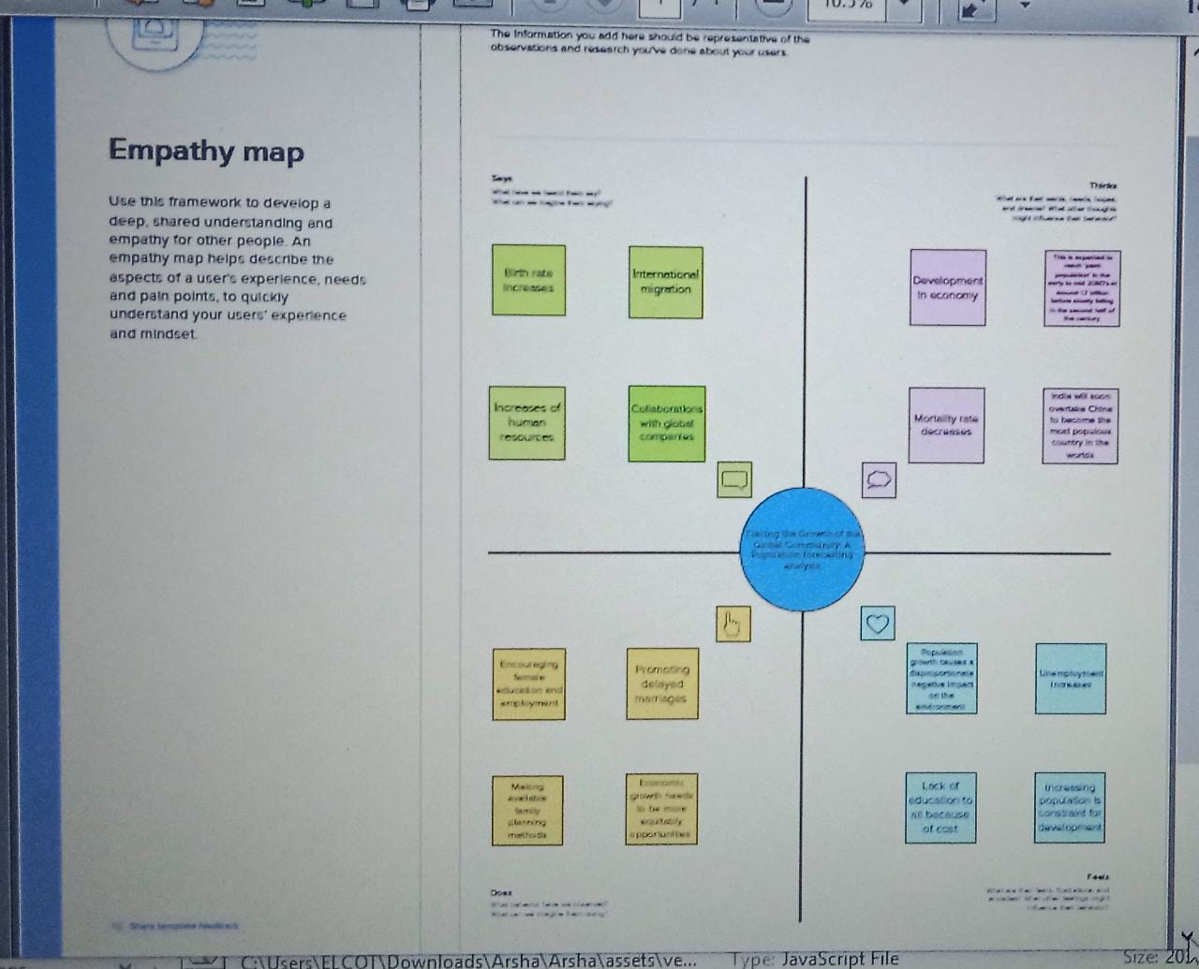

2.2 Brainstroming Map:-

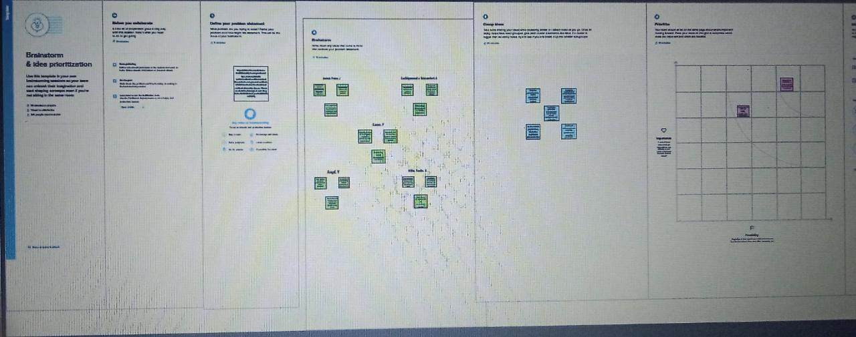

3. Results

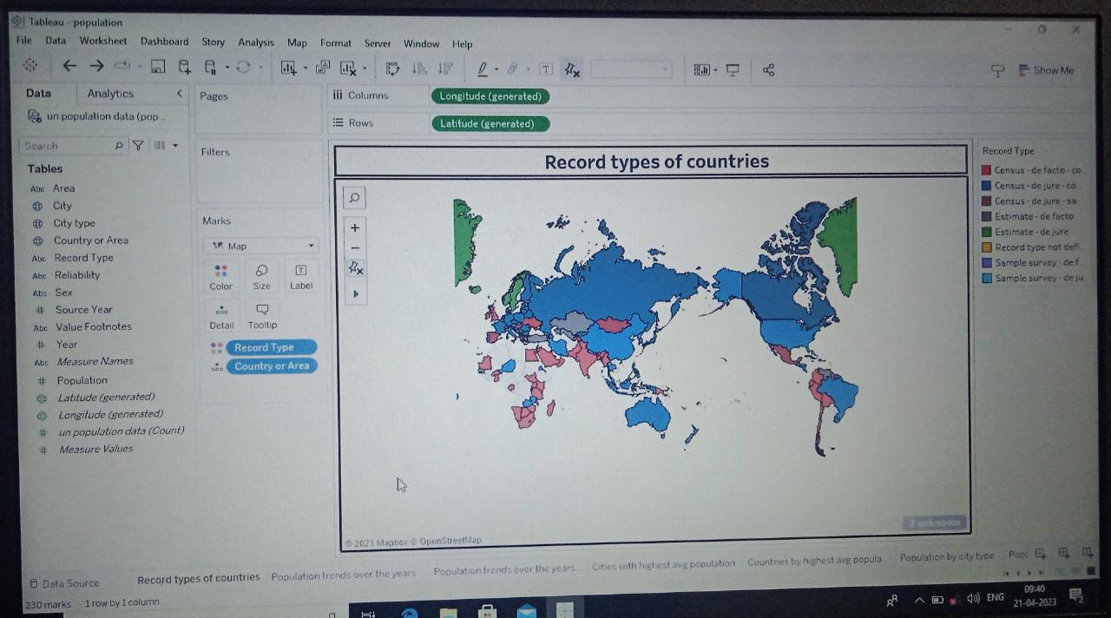

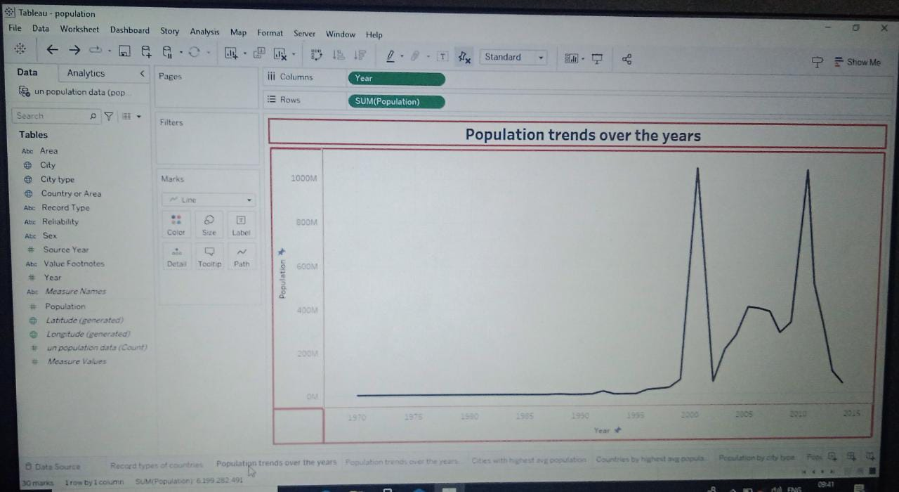

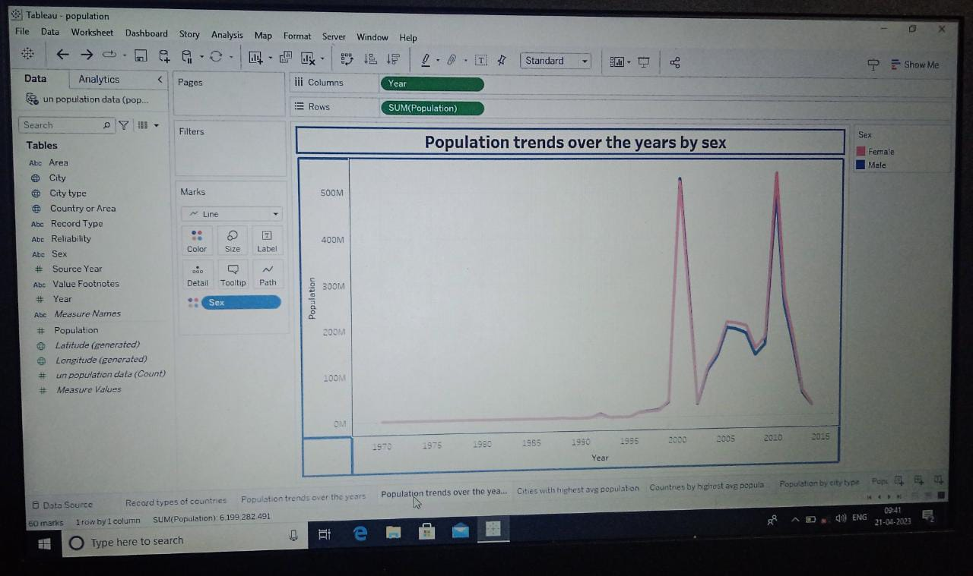

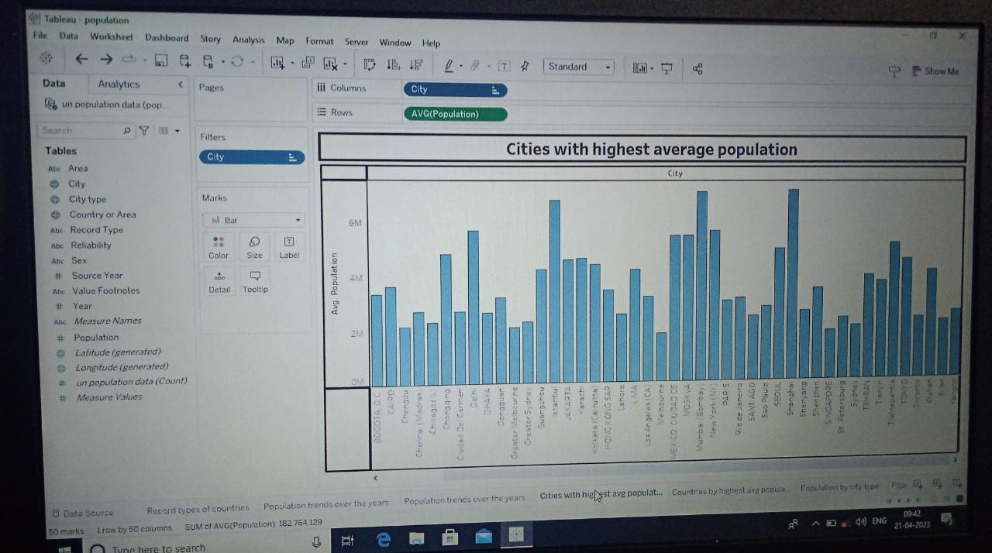

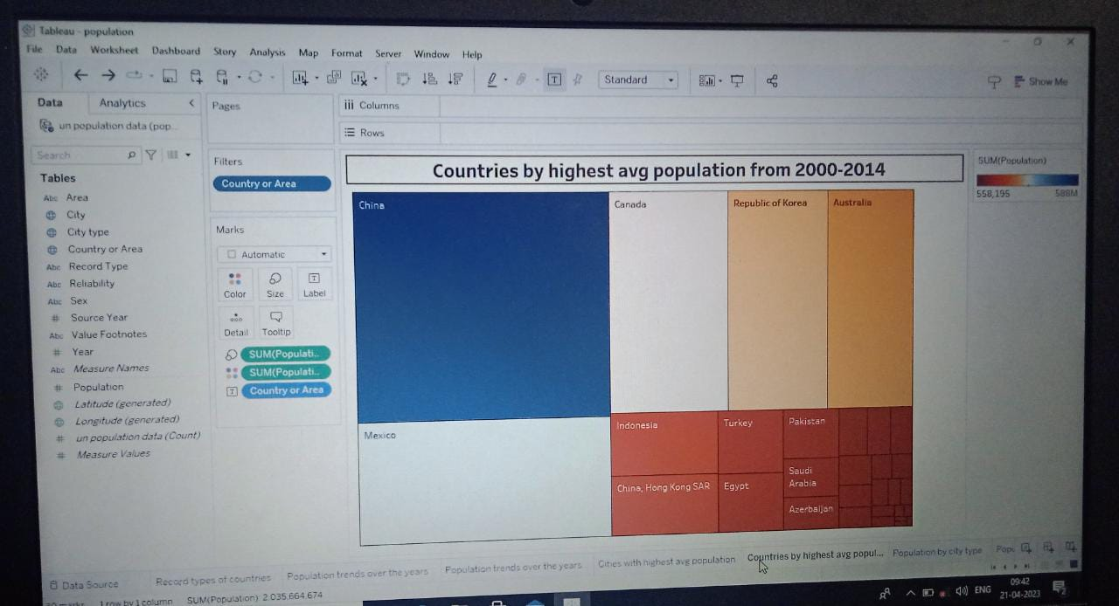

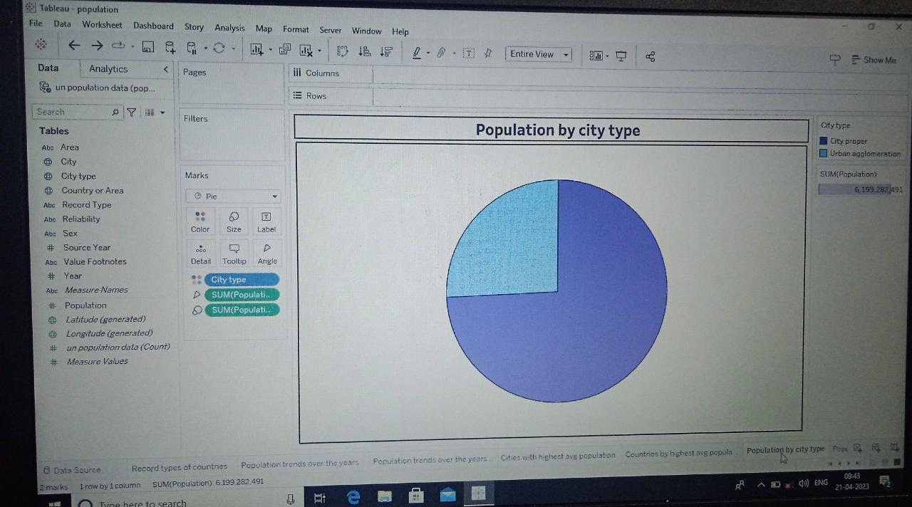

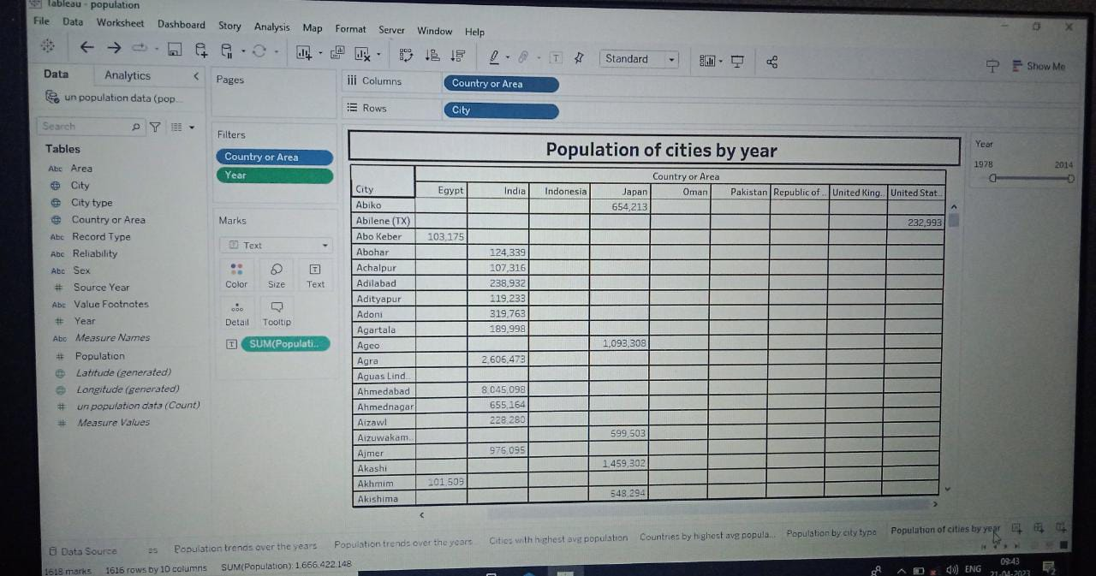

4 Advantages and Disadvantages

Advantages:-

* Estimate the basic need for human, such as demand for food, water, power, transportations.
* Plan constructions such as housing, highways etc.
* Estimate the potential consumption in various regions.
* Benefit sociological research, such as providing data about sex ratio or age ratio.

Disadvantages:-

* Unforeseen events can alter birth rates, death rates, migration, or the resources limits on population growth.
* The reliability of projections decreases over time, and projections tend to be less reliable in periods of rapid change.
* Ecological degradation, increased conflicts, and a higher risk of large –scale disasters like pandemics.
* Overcrowding, destitution, crime, pollution, and political turmoil.

5. Application

* Generously fund family planning programs.
* Make modern contraception legal, free and available everywhere, even in remote areas.
* Improve health care to reduce infant and child mortality.
* Restrict child marriage and raise the legal age of marriage (minimum 18 years).

6. Conclusion

The Earth’s current population is almost 7.6 billion people, and it is expanding. It is expected to surpass 8 billion people by 2025, 9 billion by 2040, and 11 billion by 2100. The population is quickly increasing, far surpassing our planet’s ability to maintain it, given existing habits.

7. Future Scope

Global population growth is determined by the number of births and deaths. Improving health is increasing the size of the population as it is decreasing mortality. The countervailing trend is falling fertility rates – the trend of couples having fewer children is what brought rapid population growth to an end in many countries already, and what will bring an end to rapid population growth globally.

The UN projects that the global population will increase for a population of around 8 billion in 2022 to 10.4 billion by the end of the century. By that time, the UN projects, fast global population growth will come to an end.

------